Project title: Quantifying carbon emissions from forest burning in Central Africa and assessing their potential economic value
Research Themes: Climate Change, Changing Planet
Keywords: Carbon emissions, deforestation, biomass burning, atmospheric composition, Earth Observation.
Lead Supervisor: Dr Anita Ganesan (School of Geographical Sciences, University of Bristol)
Co-Supervisor: Professor Michael Finus (Department of Economics, University of Bath)
Co-Supervisor: Dr Joanna House (School of Geographical Sciences, University of Bristol)
Co-Supervisor: Dr Matt Rigby (School of Chemistry, University of Bristol)
Project Enquiries: anita.ganesan@bristol.ac.uk
Host Institution: University of Bristol, Faculty of Science, School of Geographical Sciences

Background

The change of land from forested to agricultural regions is a large contributor of greenhouse gases to the atmosphere. The Congo Basin contains the second largest rainforest in the world and the majority of deforestation in the Democratic Republic of the Congo DRC) is by subsistence farmers, who rely on slash-and-burn methods to convert forests into to agricultural land. Initiatives such as the United Nations REDD+ (Reducing Emissions from Deforestation and Forest Degradation in Developing Countries) are in the early stages for implementation in Congo Basin countries to offer direct financial compensation for the carbon emissions ‘avoided’ through protection of forests.

Project Aims and Methods

One of the key components of assessing whether REDD+ policy targets are being met is to have robust accounting of the carbon dioxide and methane emissions associated with burning of forests. In this project, we will use data of atmospheric carbon dioxide, methane and carbon monoxide (a tracer of burning) from satellites to quantify carbon dioxide and methane emissions from biomass burning in Central Africa. The student will run the UK Met Office NAME model, a high resolution atmospheric transport model, to provide the link between concentrations and emissions. These components will be brought together through a state-of-the-art statistical framework developed by the team. The goal of this component of the project will be to quantify biomass burning carbon emissions from the region over the past decade. This will be used to assess a baseline from which to evaluate changes in the future and will provide a method for independently assessing the inventories used to quantify emissions for submission to REDD+. This complementary approach has been identified through global initiatives such as the World Meteorological Organisation’s IG3IS (Integrated Global Greenhouse Gas Information System) as being a vital component of verifying and monitoring progress towards policy targets.

The carbon quantified from biomass burning of forested regions will then be translated into an economic value through the frameworks proposed by REDD+ initiatives in DRC and in other countries. Based on the newly refined understanding of the carbon emissions associated with burning of these forests, the student will investigate whether the REDD+ framework for these countries need be amended to meet the needs of the community. Future land use scenarios will also be investigated, using the present-day quantification of carbon emissions as a baseline, to determine the economic potential of this policy.
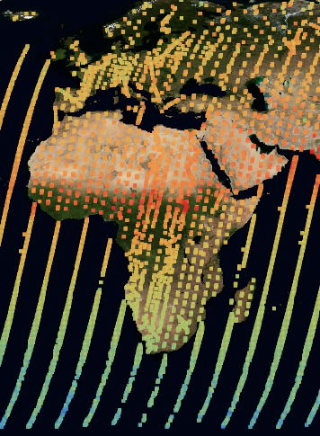
Caption: Methane concentrations observed over Africa by the GOSAT satellite (UK National Centre for Earth Observation).

About the Doctoral Training Partnerships

Studentships are fully-funded, covering tuition fees and providing the student with a stipend for 3.5 years at Research Council rates, currently £14,553 p.a. The student will have a total of 4 years to submit their thesis.

The student will belong to both the NERC GW4+ DTP and the ESRC SWDTP and will be required to attend their compulsory training and cohort-building events and encouraged to participate fully in other training, courses and events run by the DTPs, including taking up work and policy placement opportunities not directly linked to their research areas.

The NERC GW4+ DTP and SWDTP will also provide a Research Training Support Grant (RTSG) for research consumables including lab, computing and fieldwork equipment,

How to apply for this project
Apply through the University of Bristol online applications portal: http://www.bristol.ac.uk/study/postgraduate/apply/

IMPORTANT: When applying online, please select ‘Geographical Sciences: Physical (PhD) Programme’ and on the ‘Research Details’ page answer ‘Yes’ to the question about responding to a specific studentship advert and provide the full project title in the freetext box.

Application deadline: 1600 hours GMT, Monday 12 February 2018

Links:
School of Earth Sciences: http://www.bristol.ac.uk/earthsciences/courses/postgraduate/
NERC GW4+ DTP Website: http://nercgw4plus.ac.uk/ ESRC SWDTP Website: https://www.swdtp.ac.uk
General Enquiries to Bristol NERC GW4+ DTP Administrator: bristol-nercgw4plusdtp-admin@bristol.ac.uk

