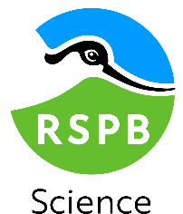

Lessons learned from conservation livelihood interventions in the Guinea Savannah Landscape of Ghana
2 x 3-month PhD student placement opportunities at the RSPB
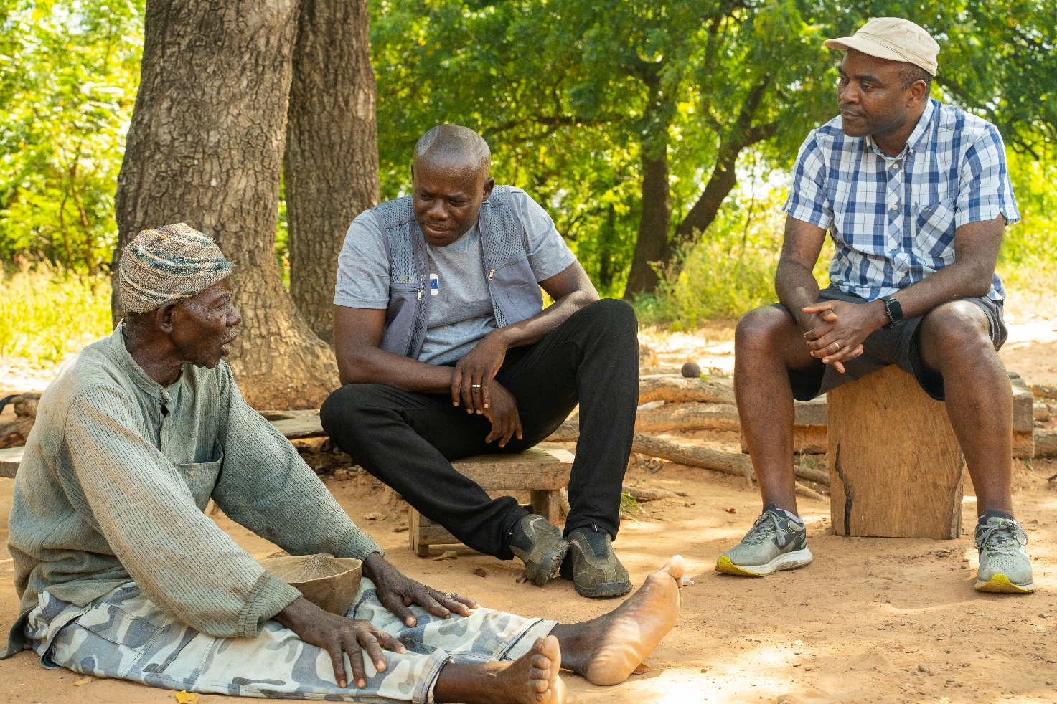
Photo Credit: RSPB/Nick Williams (rspb-images.com)

The RSPB’s Flyways Conservation Programme seeks to secure a network of sites and landscape-scale interventions along the East Atlantic Flyway (a bird migration route that extends from the Arctic though Europe and West Africa, to Southern Africa). Within this flyway, the Guinea savannah of Northern Ghana is a priority landscape for RSPB, where we are working with Ghana Wildlife Society to create high impact nature conservation, supporting livelihoods and contributing to stabilising the climate. Integrating livelihood interventions alongside conservation and restoration activities is essential in this landscape, as most of the population live below the poverty line and are directly reliant on natural resources for their income. Although there have been numerous livelihood interventions delivered by government agencies and NGOs, outcomes have been mixed. Before RSPB undertakes any new livelihood interventions in the landscape, it is essential to review and evaluate these previous activities, to understand what has and has not been effective. We have two linked 3-month PhD placements available to inform interventions, with the potential to improve community livelihoods and conservation outcomes through enabling conditions for success.

Placement 1: Scoping Review of livelihood interventions in Ghana
This is a desk-based project that would require a student to complete a scoping review of the relevant academic and grey literature on conservation livelihoods in the Guinea Savannah in Ghana. They would then present a report that provides a critical assessment of this literature with key recommendations for future livelihood development, accessible to non-specialists. The report would develop a catalogue and map of nature conservation-based livelihood interventions, identify co-benefits and the impact of livelihood interventions on biodiversity and nature conservation and barriers and enabling factors determining the successful implementation of livelihood interventions. The findings would be disseminated through an online workshop with key stakeholders and used by the RSPB as guidance for factors to consider when developing livelihood interventions for future funding applications and could also potentially be submitted for publication to a peer-reviewed journal.

What skills and experience would be useful?
- Ability to read, synthesise and critically analyse scientific literature.
- Report writing in a style accessible to non-specialists.
- An understanding of the challenges and success factors influencing conservation livelihood interventions internationally.
- Interest and/or experience in international biodiversity conservation and the social sciences.

What skills, expertise and experience would the student develop?
- Literature review and critical analysis.
- Experience of developing an online dissemination workshop with key stakeholders.
- Development of a professional network with staff working in conservation science, international conservation programme management and policy.

Placement 2: Qualitative and thematic analysis of practitioner insights
This also a desk-based position that will involve conducting online interviews with NGOs and conservation practitioners to identify lessons learnt from implementing livelihood interventions in Ghana and analysing pre-existing interviews. Interviews would be analysed using a qualitative thematic analysis in N-Vivo. The results will be written up into a report highlighting key findings and recommendations for future livelihood development. The report would focus on identifying co-benefits or the impact of livelihood interventions on biodiversity and nature conservation and barriers and enabling factors for success in the Guinea Savannah area in Ghana. The report would be disseminated through an online workshop with key stakeholders and used by the RSPB to develop future interventions. It could also potentially be submitted for publication to a peer-reviewed journal.

What skills and experience would be useful?
- Strong interpersonal and listening skills and the ability to conduct semi-structured interviews online.
- Experience of undertaking qualitative data analysis/ or thematic analysis in N-Vivo.
- Report writing in a style accessible to non-specialists.
- An understanding of the challenges and success factors influencing conservation livelihood interventions internationally.
- Interest and/or experience in international biodiversity conservation and the social sciences.

What skills, expertise and experience would the student develop?
- Comprehensive qualitative data analytical skills and critical analysis.
- Experience of developing an online dissemination workshop with key stakeholders.
- Development of a professional network with staff working in conservation science, programme management and policy.

Placement details

Location
Both roles can be done remotely, or a workspace can be arranged at RSPB offices in the UK. Working in, or regularly attending, the RSPB offices in Cambridge or Edinburgh would give a student the greatest opportunity for in-person interaction with key RSPB science, programme management and policy staff involved in this project. The Cambridge offices are located within the Cambridge Conservation Initiative which houses ten conservation organisations with communal facilities and events, so being in Cambridge would also allow the student to take advantage of these network development opportunities.

Funding
We are able to provide up to a £500 contribution for subsistence and travel costs to attend in person meetings in line with RSPB’s expenses policy. However, there is no core funding available through the RSPB for placement, and this would need to be provided through the student’s PhD training programme.

RSPB contact
Email Natasha Constant (natasha.constant@RSPB.org.uk) stating what role you’re interested in, a brief motivation letter and C.V ASAP. We’re hoping for placements to start during the summer 2026, with a duration of around three months. The exact start date is flexible and can be agreed with successful candidates to fit around their PhD commitments.

